Beth Keel
Appendix
Energy Star Award of excellence – Affordable Housing

The following pages contain appendices 1 through 5 of supporting documentation for the San Antonio Housing Authority’s 2013 Energy Star Award Application; Excellence in Affordable Housing.
San Antonio Housing Authority (SAHA)
818 S. Flores
San Antonio, TX 78204
210-477-6242

Appendix 1
Vibrant Communities: Where People Thrive
President and CEO’s Message: A Bright Future Realized
Imagine a community where all children have access to quality education, where adults come home from work and still have the energy to attend a community meeting, where senior citizens are actively engaged in a myriad of social and recreational activities, and where person without shelter has the support necessary to have a place they can call home. This is the community SAHA works to make a reality across our city- to create vibrant communities where everyone thrives.
We believe these communities are possible, and our commitment to join with our partners to make them a reality is steadfast.
SAHA provides housing to nearly 70,000 youth, seniors and adults, including a significant number of disabled individuals and their families. To better serve our families and seniors, and protect our housing assets, we invested $20 million of American Recovery and Reinvestment Act (ARRA) funds for upgrades at 37 public housing communities. This prudent investment created nearly 300 jobs and more than $60 million of direct, indirect and induced economic activity in San Antonio.
With nearly 20,000 families on waiting lists for our housing programs, there is a dire need for affordable housing in our community. We are committed to preserving and expanding the supply of housing for low-income communities: HemisView Village, Sutton Oaks I, The Mirabella, San Juan Square II and Artisan Creek.
In addition to preserving and building housing, we provided $86 million in housing assistance to 13,289 families, including approximately 200 homeless individuals or families and nearly 130 homeless veterans, through our Section 8 and special program vouchers, which received a high performer rating from HUD.
For our families to thrive, other educational, economic and social opportunities are often needed. SAHA’s new Community Development Initiatives department assists families in their efforts to achieve self-sufficiency, with access to job training, educational opportunities, and support services, such as childcare, transportation, and employment opportunities.
In the last year, we expanded and enriched the Moving to Work (MTW) efforts by forming 58 partnerships to increase our clients’ access to resources in education, employment, health and wellness, and much more. The MTW designation allows SAHA the flexibility to design and test new policies and programs to better serve the needs of our local community. Utilizing these flexibilities along with other opportunities, we housed 1,395 more families, while being more cost efficient through administrative changes, such as implementing biennial recertification’s for elderly and disabled families on fixed incomes.
To further resident leadership, we re-ignited our public housing Resident Councils, growing from 15 Councils in 2009 to 34 Councils today. In addition, $3.9 million of grant revenue was secured, from both public and private funders, including New York City’s Social Innovation Fund’s Jobs-Plus Grant, the Centers for Disease Control/Metropolitan Health District health and wellness grant, HUD’s Choice Neighborhoods planning grant, as well as federal self-sufficiency grants.
SAHA has also established specific procurement goals and contractor expectations to expand business opportunities with small minority-owned businesses. The outreach efforts to Section 3-qualified vendors have been strengthened and recruitment efforts to resident employees broadened, resulting in a growth from no Section 3 vendors to 17 today.
A major victory came in May 2011. After years of a long-standing lawsuit with the neighborhood’s builder and subcontractors, SAHA and 66 Mirasol homeowners finally reached a settlement for a total of $20 Million. With this victory, the settlement now allows us to begin the efforts to rebuild the Mirasol community.
The core of what we do is about people. In 2011 and beyond, we will continue efforts to improve our clients’ quality of life, preserve and expand affordable housing, enhance the management and delivery of our programs, and implement innovative and focused solutions to address the need for affordable housing.
With our visionary Board of Commissioners, a skilled and dedicated staff of nearly 600, and collaborative partners, SAHA will continue vibrant communities where people thrive.

Lourdes Castro Ramirez
President and CEO

Appendix 2
Board Approved: Preservation and Expansion Policy
AFFORDABLE HOUSING PRESERVATION & EXPANSION POLICY
1. Summary
The Affordable Housing Preservation & Expansion Policy establishes the principles, goals, priorities, and strategies of the San Antonio Housing Authority (SAHA) regarding the construction, maintenance, rehabilitation, and disposition of housing assets. The Policy governs where and under what conditions specific types of housing are built, renovated, disposed, or liquidated. The Policy establishes parameters by which to evaluate future decisions related to affordable housing preservation and expansion activities.
The Policy is composed of the following sections:
• The Background section describes the actions and decisions that led to the adoption of this Policy
• A description of the Guiding Principles that shaped the broad outlines of this Policy
• A listing of the Targeted Outcomes that serve as the key goals of this document
• A detailed outline of the Strategic Framework that shapes implementation
• A statement regarding Implementation and Monitoring steps
• A list of pertinent Definitions
2. Background
This Policy is a product of iterative and cumulative feedback from the SAHA Board of Commissioners, public and private sector stakeholders, and staff from partner agencies.
In the summer of 2010, the San Antonio Housing Authority initiated a collaborative and fact based assessment of affordable housing demand, supply, and unmet need in the City of San Antonio. This process included internal and external stakeholders such as the Board of Commissioners, Mayor’s office, the Department of Housing and Urban Development (HUD), and key local public, for profit and non-profit leaders and organizations.
The SAHA Board of Commissioners held discussions during summer 2010, December 2010, February 2011 and April 2011. Stakeholder meetings were organized with non-profit and for-profit developers and public agencies starting in summer 2010. During the same time period, specific discussions with the Mayor’s office, the City of San Antonio’s Planning and Development Services Department, and Trinity University focused on how to integrate and track San Antonio housing data. Additionally, an evaluation was completed of the external funding environment, including public and private financing sources.
Prior to adoption, this Policy was considered during the following Board of Commission and Committee meetings:
• January 6, Operations and Human Resources Committee
• January 13, Regular Board Meeting
• February 24, Operations and Human Resources Committee
• April 21: Operations and Human Resources Committee
• May 12: Regular Board Meeting
3. Guiding Principles
This Policy has been developed under the guidance of the following principles, which also direct subsequent implementation and work plans.
A. SAHA is committed to transparently plan, collaborate, and act in coordination with residents, program participants, and public, private, and non-profit stakeholders at the local, state, and federal level, including City agencies, Mayor’s office, City Manager, VIA, and school districts
B. SAHA will ensure that strategies and approaches are in alignment with HUD’s 2010-2015 Strategic Plan
C. SAHA recognizes the significant unmet need for quality housing affordable to lower income individuals and families in San Antonio and commits to:
• work actively to preserve and expand quality affordable housing to fill that need
• pursue rehabilitation, acquisition, new construction, or asset repositioning projects to address that unmet community need
D. SAHA believes housing can be a catalyst for economic development and community vibrancy and commits to:
• assist residents in making socio-economic progress so their families can transition from government support and ultimately sustain themselves
• stimulate economic development through the creation of financially, socially, and environmentally inclusive communities that are healthy and sustainable

4. Targeted Outcomes
This Policy establishes the following targeted outcomes as the key goals of this Affordable Housing Preservation and Expansion Policy.
A. Add high quality, sustainable, and affordable housing to San Antonio
B. Improve the quality of existing housing and enhance its useful life
C. Achieve a distribution of mixed-income communities throughout San Antonio
D. Realize significant positive socio-economic impact on our residents and communities
5. Strategic Framework
To achieve this Policy’s Targeted Outcomes, a Strategic Framework has been developed to structure and prioritize SAHA’s affordable housing preservation and expansion activities. The Strategic Framework is made up of four global strategies – Preserve, Revitalize, Expand, and Place Based Initiatives (P.R.E.P.) – and eight specific strategies.
A. P.R.E.P. Global Strategies
1. Preserve Housing Stock
a) Meet housing and property quality standards established by the Real Estate Assessment Center (REAC) and Texas Department of Housing and Community Affairs (TDHCA), as well as the Housing Quality Standards (HQS) established by HUD
b) Prioritize comprehensive modernization or substantial rehabilitation projects
c) Liquidate assets to preserve or enhance affordable housing
2. Revitalize Communities
a) Redevelop public housing into mixed-income and service-enriched communities
b) Develop community revitalization plans with stakeholders
3. Expand Affordable Housing
a) Expand the supply of affordable housing units
b) Acquire housing projects or land for affordable housing/mixed-income
4. Place Based Initiatives
a) Carry-out resident socio-economic development and economic development activities
b) Provide supportive housing for special populations
B. Specific Strategies
1. Address Community Need. SAHA is primarily focused on addressing unmet need that is not being adequately addressed by the private market and where therefore a government subsidy is needed.
a) Lead (by building or acquiring) or support projects (for capital generation) which fulfill a community need for affordable housing
b) Determine and document community need using objective market analysis, including SAHA’s waiting list information
2. Locate Projects Strategically. Recognizing that the location of an affordable housing preservation or expansion project can be a major driver of the long term success of the project and the socio economic opportunities and challenges available to residents, SAHA will:
a) Pursue acquisition and/or partnership opportunities synergistic with other community initiatives
b) Focus on a project’s accessibility to education, job training, employment opportunities, and location amenities (e.g., recreation, health, retail, spiritual)
c) Pursue development projects linked to transportation and employment opportunities
3. Establish Affordable and Sustainable Standards for Housing Development and Redevelopment. SAHA is committed to redeveloping existing housing projects as well as developing new projects consistent with the following:
a) Develop mixed income communities that are healthy and encourage socio-economic integration
b) Maintain at least 20 percent of units as affordable for community members earning below 30% area median income
c) Replace all removed public housing units with a unit or housing choice voucher affordable at an equivalent level. Replacement units may be located at other sites.
d) Focus primarily on creating family units and supportive housing for special needs populations
4. Establish Sustainable Building Design, Standards, and Compliance Practices. SAHA is a property manager, owner, and/or developer with a long-term community-focused mission. Understanding that building codes and developer or sub-contractor construction standards may not fully incorporate this long term property management and maintenance perspective, SAHA will:
a) Develop agency-specific construction and materials standards to achieve long term and cost efficient management and maintenance of SAHA communities
b) Build all development and redevelopment projects to SAHA’s construction and materials standards and “Build San Antonio Green level 2”
c) Incorporate sustainable concepts and practices into development design
d) Adopt a smoke-free policy at all developments
5. Invest to preserve and extend the useful life of properties. Given the wide gap between community need and actual affordable housing supply, SAHA will focus on investing prudently to both preserve and extend the useful life of its properties.
a) Ensure that property improvements enhance housing quality, livability standards, and marketability
b) Proactively plan for and implement comprehensive rehabilitation (e.g., total building vs. system by system approach)
6. Incorporate Long Term Financial and Planning Considerations. SAHA will be proactive in developing and implementing a realistic long term financial plan for each project so that San Antonio’s affordable housing stock is maximized.
a) Include analysis and/or plan for maintenance, replacement, compliance, and funding in all new development, redevelopment, refinancing, acquisition, and liquidation projects and pro-formas
i. Include a realistic long term financial projection including the construction period, lease out period, and post-compliance period for all projects. Rent and lease out/vacancy assumptions must incorporate an analysis of competing current and planned projects in the neighborhood
ii. Develop agency-specific underwriting criteria and standard management and operating agreements
b) Ensure that all projects meet SAHA’s general underwriting criteria and standard agreements
c) Value the economic contribution of SAHA’s tax exempt status and negotiate project economics commensurate with this value contribution
d) Consider for liquidation all assets that are not performing well or land without significant development potential
e) Reinvest revenues generated from these activities into preserving or expanding affordable housing
7. Adopt an integrated approach to socio-economic development. In order to support resident and community socio-economic development, SAHA will:
a) Focus on developing properties where key amenities are accessible e.g., schools, banking, grocery shopping, employers, and public transportation
b) Maximize Section 3 resident employment opportunities, both short term and long term
c) Increase business activities with small, minority owned, local, and women owned businesses
d) Utilize SAHA’s ‘Moving to Work’ designation to expand housing options and create economic opportunities so residents can achieve economic self sufficiency
e) Partner with residents as well as public, non-profit, and for-profit organizations to provide educational resources, job training, and supportive services to help families become economically stable
f) Work together with economic development organizations to realize emerging economic development opportunities by creating mixed use and mixed income communities
8. Plan with Residents and Community Stakeholders. Residents and community members must be offered the opportunity to contribute meaningfully in advance of the design of any planned projects and their input shall be incorporated.
6. Implementation and Monitoring
This Policy applies to all of SAHA’s affordable housing preservation and expansion initiative, transactions, and activities.
Implementation and monitoring of this Policy is the primary responsibility of the Development Services and Neighborhood Revitalization (DSNR) team, but is also the responsibility of the following SAHA teams: Housing Choice Voucher, Property Management, Finance, and Community Development. A policy exception must be requested by staff and granted by the Board of Commissioners in all relevant cases.
Finally, staff will develop a policy implementation work plan and detailed guidelines to implement this policy. Staff will regularly evaluate and update the aforementioned work plan and guidelines
7. Definitions
Place Based Initiatives - Place-based policies leverage investments by focusing resources in targeted places and drawing on the compounding effect of well-coordinated action. Effective place-based policies can influence how rural and metropolitan areas develop, how well they function as places to live, work, operate a business, preserve heritage, and more
HQS – HUD Housing Choice Voucher (HCV) program regulations set forth basic housing quality standards (HQS) which all units must meet before assistance can be paid on behalf of a family and at least annually throughout the term of the assisted tenancy. HQS define "standard housing" and establish the minimum criteria for the health and safety of program participants.
Section 3 – A means by which HUD fosters local economic development, neighborhood economic improvement, and individual self-sufficiency. Section 3 is the legal basis for providing jobs for residents and awarding contracts to businesses in areas receiving certain types of HUD financial assistance.
Under Section 3 of the HUD Act of 1968, wherever HUD financial assistance is expended for housing or community development, to the greatest extent feasible, economic opportunities will be given to Section 3 residents and businesses in that area.

Appendix 3

New Developments:
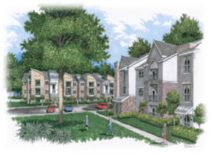
1. The Park at Sutton Oaks (Sutton II)-broke ground 2012
208- mixed income units
Entire complex will be built to Energy Star, Water Sense, and Indoor airPlus criteria. During development, all insulation will be grade one installation. Products will be low or no Volatile Organic Compounds (VOCs) and built to Level 2 Build San Antonio Green (BSAG) standards. Level 2 is 25% above International Energy Conservation Code (IECC) of 2009. BSAG is the local green buildings program for San Antonio.
http://www.ksat.com/news/East-side-SAHA-project-entering-Phase-2/-/478452/16921672/-/a2vpcxz/-/index.html
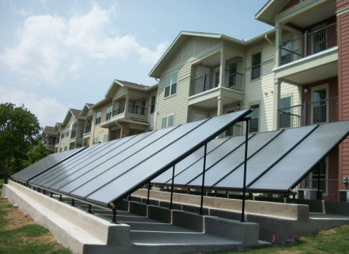
2. The Mirabella
172- Affordable senior development units
In order to ensure that the Mirabella will exceed the energy efficiency standards, the project will obtain Build San Antonio Green certification. BSAG has been very instrumental in Mirabella to make sure that it exceeds COSA ordinance standards by a minimum of 15%. Mirabella has gone through stringent testing through a third party Energy Star verifier. A Thermal Bypass Inspection was preformed to document effective sealing of any potential air leakage, insulation continuity and proper insulation of all envelope layers. A Thermal Imaging test was used to identify any energy loss that is invisible to the naked eye. Finally, a Blower Door and Duct Test were used to pressurize a sampling of units from the building in different locations and orientations to get an average of the overall development’s performance.
The overall operation cost of the building is projected to be between 10-15% less than other buildings in the area due to all of the sustainability features and cost savings measures included.
Energy Star appliances, ceiling fans, and lighting were installed throughout the complex. Mirabella chose Energy Star in order to provide residents with lower utility bills, improved quality and durability of products and high performance compared to other non-qualified products. All light fixtures feature CFL bulbs that use up to 75% less energy than incandescent bulbs and average 10,000 hours of lighting compared to 800-1,500 hours with incandescent lighting.
The Multi-family complex is designed with a solar water heating system that not only provides hot water but also uses a heat pump to heat the building and the living spaces. Partially enclosed breezeways help maintain the ambient temperature within the buildings helping to reduce the need for as much heating or cooling. Energy efficient doors, windows, appliances and HVAC were all included. Covered balconies and porches help reduce heat absorption through sliding doors.
The benefits of the solar hot water system is that depending on the conservation knowledge of the residents, the utility bill can be up to 30% less than a comparable building. For a multi-family community, that is a substantial savings over the life of the development.
The Mirabella’s solar water heater system is set up with 3 well-insulated water storage tanks with a 1000-gallon capacity. The water heats through the panels and is preheated before it hits the individual water heaters within the units. The solar water heater heats the water for sinks, showers and, with the use of a heat pump, heats the units.
Mirabella has hydronic heat pumps for the units. The water heats through solar panels and is preheated before it hits the individual water heaters within the units. The hydronic heat pump uses the unit’s hot water heaters in an open loop system through an evaporator where the heat in the water is extracted by the refrigerant.
Programmable thermostats were installed to increase comfort, convenience, and help save energy at Mirabella. Along with the Comfortmaker High Efficiency 14 SEER Air Conditioner and the unique heat pump system, our residents have climate control at the tips of their fingers.
Mirabella has sought out water efficient products for the development. By using the Proflo 1.28 gallon flush low flow toilets endorsed by the EPA Watersense.
Cleveland shower heads at 2.0 gallons per minute and Cleveland aerators at 1.5 gallons per minute, Mirabella is estimated to be 20% more efficient than other buildings of the same size built within the past ten years.
To support our sustainable initiatives, SAHA has been looking at what will create a green and healthy home. Low VOC glues have been used to help maintain good indoor air quality. The EPA has stated that indoor air quality can be 3 to 5 times more toxic than the outdoor air due to off gassing of the paints and finishes. With that in mind, Mirabella consciously used low VOC glues to help create a healthier indoor environment for our clientele and their families. Low VOC reduces chemical sensitivities and allergens.
Mirabella has also installed wall-to-wall vinyl to help reduce allergens and microbes that typically collect in carpets. The vinyl was created by Earth Werks from Corpus Christi, Texas. The flooring is formaldehyde free, contains a minimum of 50% recycled content and can be 100% fully recycled post use. Earth Werks is registered under the Green4life program, which guarantees the product was made from post consumer recycled content.

Appendix 4
Comprehensive Modernizations/Retrofits:
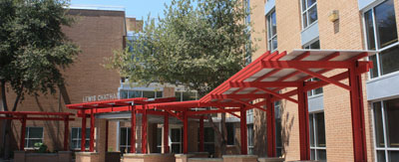
- Lewis Chatham
119-units for Elderly and Disabled

Lewis Chatham Apartments, a City of San Antonio Green Building Award winning building, was built in 1973 as an elderly community, consisting of 119 apartments in a four story, low-rise brick building. The development’s original HVAC system fell into disrepair and more maintenance was required than the cost of a new HVAC system. Replacement of the HVAC system was justified due to the long term cost savings.
Because the HVAC plan required the evacuation of the building, it was the perfect opportunity to upgrade the building and holistically modernize Lewis Chatham. The time frame was 24 months, from design to completion. What was envisioned was a total strip down of the building to its shell and upgrading to above International Energy Conservation Code (IECC 2009) for the City of San Antonio. The Request for Proposal was written to LEED standards and included the basic LEED Core Concepts: Site Selection, Water Efficiency, Energy Efficiency, Materials and Resources, and Indoor Environmental Quality. The building was executed and rated Build San Antonio Green Level 2 with an Energy Star rater/verifier. The building was found to have a better HERS rating than a new construction building above code in San Antonio, a vast improvement over the ‘70s era design.
Lewis Chatham was designed with Energy Star rating in mind, and is verified, along with Build San Antonio Green verification. The design also includes a Xeric garden to create an urban habitat. The garden included walking trails connected to the sidewalks in the community and natural bench sitting areas. There are also American with Disabilities Act (ADA) raised vegetable beds. SAHA aspires to stay above the curve for San Antonio’s mandated energy and sustainability ordinances. SAHA has received an award from Build San Antonio Green for Leadership and Outstanding Commitment.
Energy Efficiency: A variety of elements and systems contribute to the energy efficiency of the building including increased insulation, Low E windows, storefronts and the mechanical systems, upgraded lighting with CFL’s or LED’s, and a high efficiency community gas water heater.
An engineering study of Lewis Chatham determined that a Variable Refrigerant Volume Heat Recovery (VRV) system would be less expensive to install then a traditional two pipe HVAC system using a chiller and boiler. The VRV system also adds to tenant comfort. There are many days in San Antonio where the temperature swing is greater than 20 degrees needing heat in the morning and AC in the afternoon. A traditional two pipe system requires that the boiler system be turned off, cooled down, valves switched to the chiller, then the chiller fired up to provide cold water. The VRV system uses energy efficient R-410 refrigerant which allows switching from heating to cooling with a touch of the thermostat, much like a heat pump in your home. The VRV system has the flexibility to simultaneously cool and heat different zones. This allows residents on the north side to call for heat and residents on the south side to call for cooling. The VRV system will cost less to operate each year and requires less ongoing maintenance. (Please see materials and resources for more information)
Water Efficiency: Lewis Chatham is equipped with low-flow plumbing fixtures. All old plumbing fixtures were removed with the retrofit and new piping installed to insure longevity of the water systems. The building was equipped with a high efficiency community hot water heating system. It boasts to be 96% more efficient than other comparable systems. Around the building xeric landscaping area, a temporary irrigation system was installed; the system was removed before the building was occupied. (Please see materials and resources for more information)
Indoor air quality/Health Practices: The main elements for indoor air quality and health were considered when designating and selecting appropriate products for this project. All paints, primers, sealers, glues are low or have no Volatile Organic Compound (VOC). Many items including any carpeting used are third party Green Certified. The benefits to such a careful selection of material for the residents is the potential of having less sick days and feeling more energized.
Sustainable Building Products | Indoor Air Quality
D-Blaze Fire Retardant Pressure Treated Wood | No VOC’s or Formaldehyde
ITW Red Head Adhesives | No VOC’s
Owens Corning R-13 batt | Green Guard Certified and SCS Certified sustainable products
Series ES Elastomeric Sealant | Low VOC’s
Lees Broadloom | Environmentally Sustainable Carpet
Sherwin Williams: paints and primers | Complies with LEED Credits
Gold Bond Gypsum Board | Certified Green Guard
Conewed High Impact Acoustical Panels | SCS Certified
Roppe Vinyl Wall Base | CRI Green Label Plus
Decorative Wall-Mounted Lighting | Nighttime Friendly Certified Lighting
DMF Lighting Decorative LED Emergency Lights | The companies Eco Friendly design product
Carrier 24ABB3 Base 13 Air Conditioner | Puron Refrigerant

Energy Star Certified or Qualified
Epiphany | Lighting Ceiling Fans
Epiphany | Decorative Ceiling Dome
Epiphany | T8 Undercounter Lite
Epiphany | 9 ½”Mushroom Ceiling Lite
Epiphany | Ceiling or Wall Lite
Epiphany | General Purpose Strip Lites-2 Lite
Epiphany | Cast Aluminum Outdoor Elevator Lite
Liberty Lights Eco-Saver | General Purpose Troffers
Home Style Lighting | Flushmount Compact Florescent
Royal Pacific | 6” IC Airtight Florescent Housing
Home Style Lighting | 8” Mushroom Compact Florescent
Incon Lighting | 111 Series
Carrier 24ABB3 | Base 13 Air Conditioner with Puron Refrigerant
Plumbing
MOEN | Low Flow Lavatory Faucet 1.5 gmp
Eclipse | Impala Eco 2 OC HET 1.28 gpf
AO Smith | Cyclone XI Commercial Gas Water Heater

HVAC
Daikin | Mini-Splits
Daikin | VRV System individual zone controller

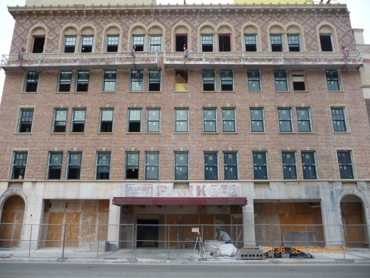
- Marie McGuire-
63 unit Elderly and Disabled property
Marie McGuire is a Historic building located in the heart of downtown San Antonio. Built in 1924, SAHA purchased the building in the 1980s. The building was in desperate need of updates and modernization. The goal for McGuire is to be BSAG certified Level 2, which is 50% post HERS improvement than pre energy testing. SAHA utilizes Energy Star raters to rate each unit pre and post HERS to obtain our goal in hitting the 50% efficiencies. McGuire is slated for completion and open by January 2013.
Public Housing Weatherization:
Weatherization (WAP) at the following properties: | William Sinkin, Matt Garcia, Frank Hornsby, H.B. Gonzalez, George Cisneros, Highview, Sun Park, Westway, Scattered single-family homes, T.L. Shaley, Midway, Riverside, Village East
Typical WAP elements included:
Infiltration measures: | caulk, switch/outlet gaskets, door sweep, and duct sealing
Attic Insulation: | increase blown in insulation, and baffle board
CFL’s: | change incandescent to CFL’s
Smart Thermostat: | Electronic thermostat
Sidewall Insulation: | increase by R-15
Refrigerator Replacement: | Replace to Energy Efficient refrigerator
Floor/foundation Insulation: | R-11
Sun Screen: | Solar screens to reduce thermal infiltration from windows
Heat Pump replacement: | energy efficient heat pumps
Water Heater Replacement: | energy efficient water heaters

Typical SAHA Purchases, information provided from Home Depot: SAHA purchases appliances from Home Depot an Energy Star Partner.
Hotpoint Dishwasher | HDA2100RWW
GE Dishwasher | HDA3600RWW
Hotpoint Refrigerator | HTH17CBTWW
GE Refrigerator | GTH18DCXRWW

ADDITIONAL AGENCY-WIDE EFFORTS:
- Peak Saver Thermostat: Upgraded in Non-Profit Family portfolio, average savings of 10% for HVAC usage of a total of 2281 units
- Replacement of 184 Energy Star Tier III washers Frigidaire Affinity ATF7000E Front Load Washer
- Required upgrade of 270 Tier III Energy Star washers and Energy Efficient Dryers in all common area laundry facilities through third party vendors
- STEP Program: Includes energy star sampling protocol with blower door and duct blaster tests. After complex qualifies the STEP program provides weatherization to the complex.
- SAWS Kick the Can Program: SAHA has partnered up with San Antonio Water Systems to replace any high flow toilets with low-flow Water Sense 1.28 gpf dual flush toilets. We have saved over 98,000,000 gallons of water with this partnership to date.

Appendix 5
Presentations given to local Texas HUD Energy Efficiency Conference, Clean Air Through Energy Efficiency (CATEE) Conference, Residents, Staff, or SAHA Board of Commissioners.

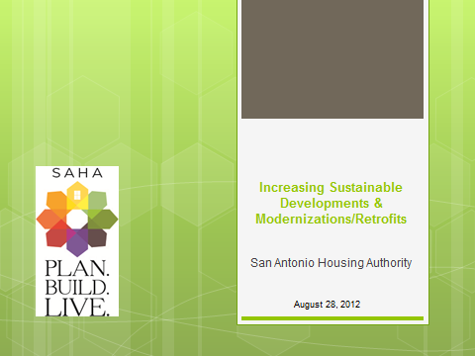
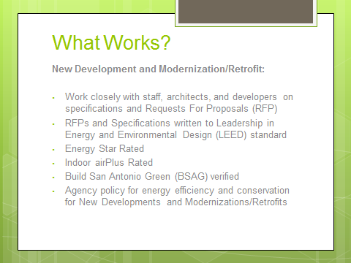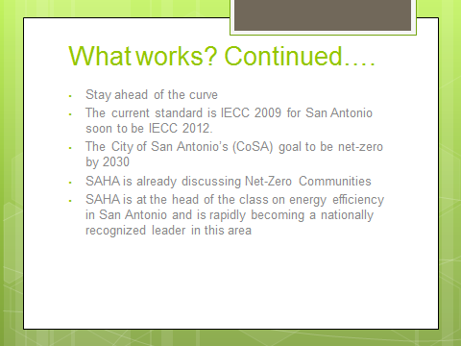
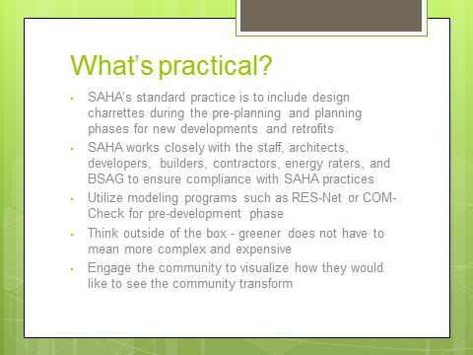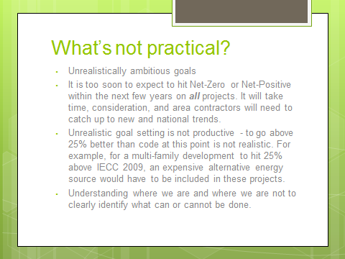
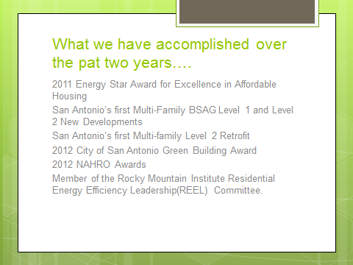

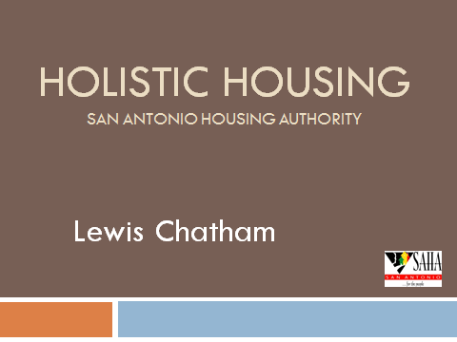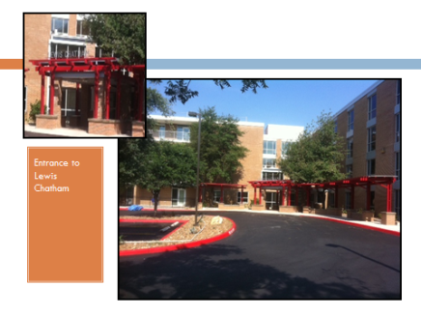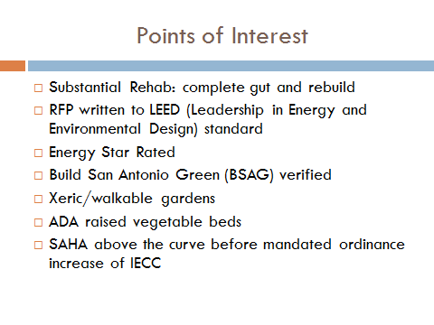
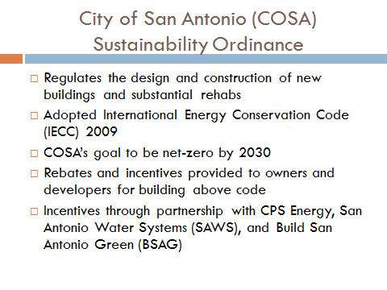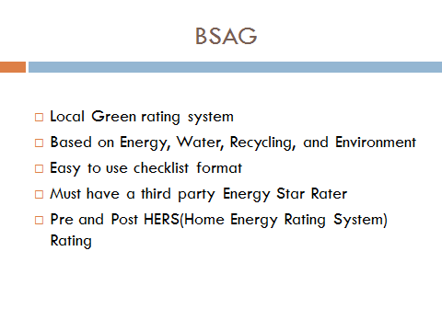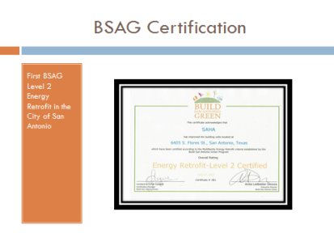
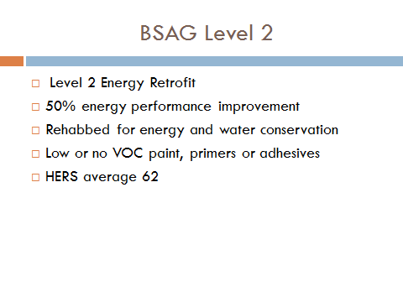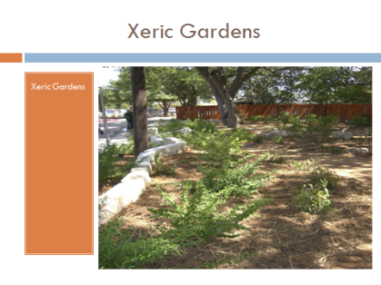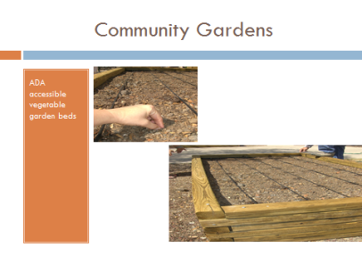
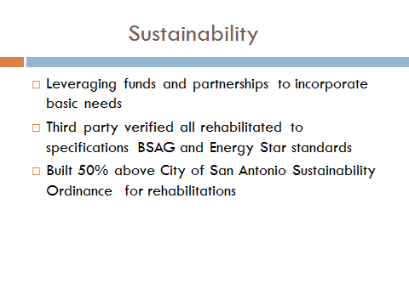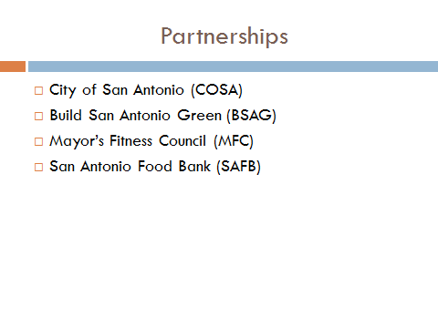
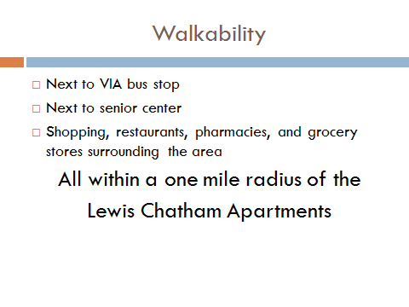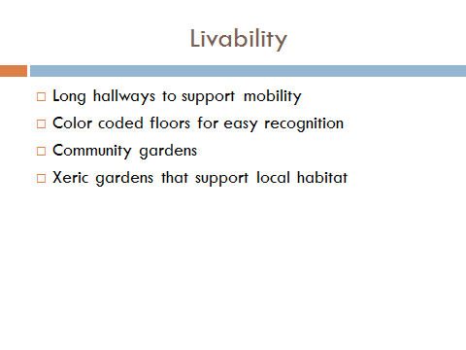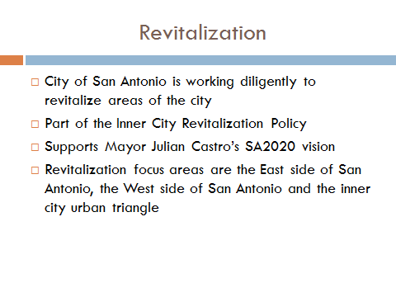
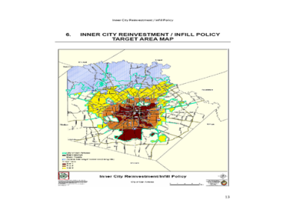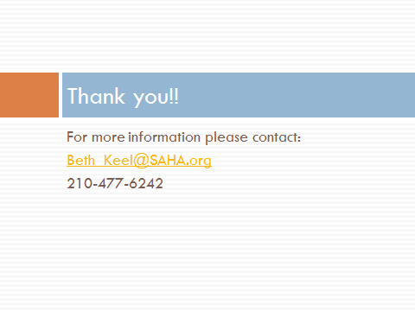

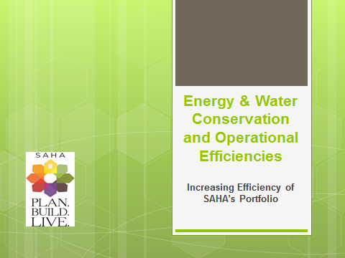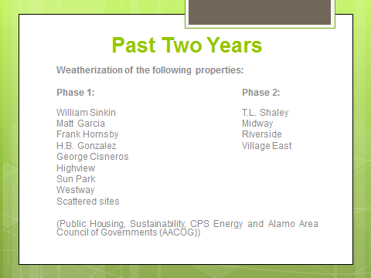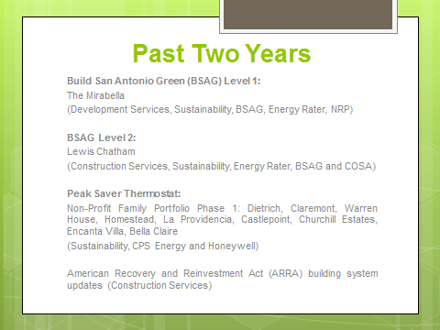
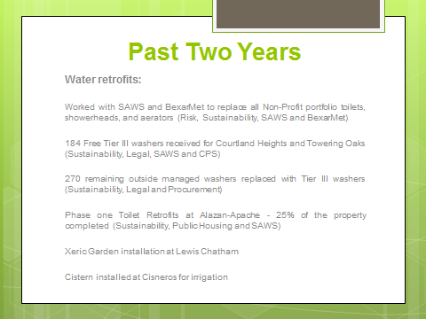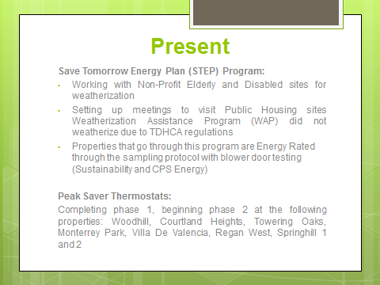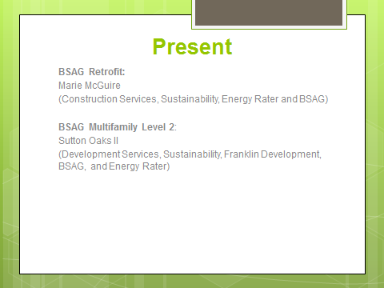
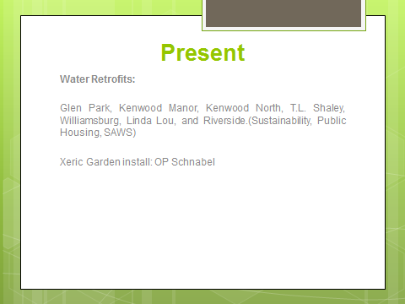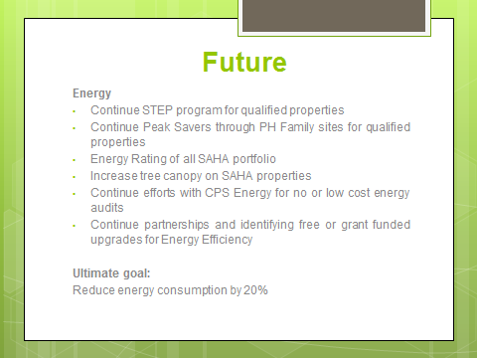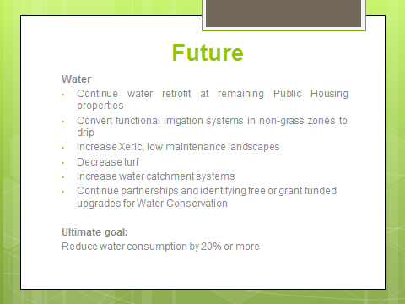
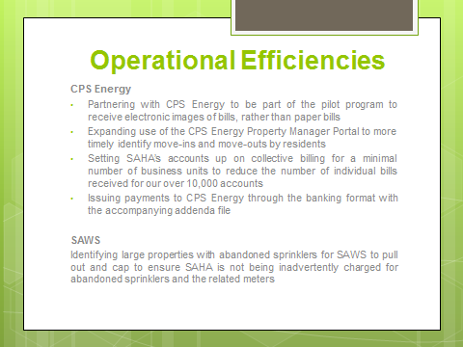

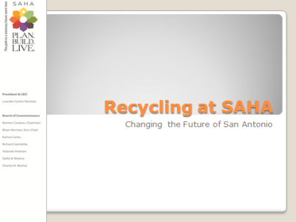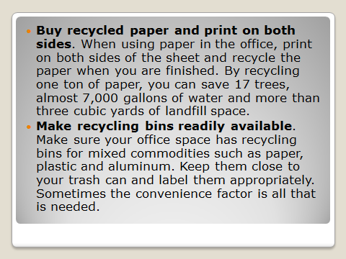
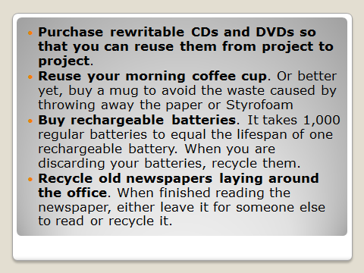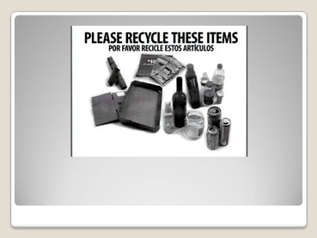
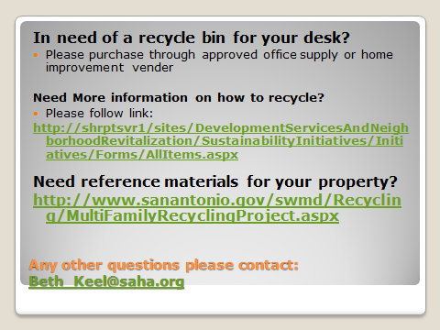

Education in SAHA Resident Handbook:

The San Antonio Housing Authority is fully committed to providing safe, affordable housing in a cost efficient and environmentally conscious manner. All households rely on utilities such as electric, natural gas, and water service to meet basic, everyday needs. Each day, we use these utilities, by practicing energy conservation, you can develop habits to reduce your energy usage and save money on your utility bills. There are a number of things you can do to save on the energy you use every day, throughout your day. Recruit everyone in the family to do their part to conserve utilities. In addition to conserving utilities in your unit there are a few option to help you manage utility bills paid to the utility company, most companies offer a budget billing program, where the cost of your energy usage is spread out over a 12-month period. With budget billing, you pay a set amount each month. If you would like more information about electric and natural gas budget billing contact your utility company.
Keep these tips in mind too:
Summer Cooling
• During the day, block the heat from the sun by closing windows, doors, and curtains.
• To save money on cooling costs turn the thermostat to 80 degrees or higher when you are sleeping or away from home. Raising the temperature by 5 degrees for eight hours can reduce your cooling costs by 3-5 percent.
• Avoid creating unnecessary heat and humidity in the house during summer days. Plan to do heat and moisture-creating activities such as washing dishes, doing laundry, bathing, and cooking before noon or past 8 p.m.
• Limit the amount of time you run kitchen and bathroom exhaust fans. Only run them for as long as it takes to get rid of any odors to minimize losing cool air.
• If you use a window air conditioning unit, make sure it fits correctly into the window to reduce the amount of cool air lost.
• Use ceiling, window or portable electric fans in occupied rooms to circulate air and make a room feel cooler. Don’t forget to turn off fans when you leave the room!
Winter Heating
• Close draperies at night and on cloudy days and open them on sunny days
• Use a sunny room as living space to read the paper or eat a meal on sunny, cold days. Upholstered furniture will soak up the heat when placed in a sunny spot.
• Lower your thermostat to 65 degrees while you’re away during the day.
• Use more blankets in bed at night to keep your body warm enough without warming your whole home.
• Dress warm. Wear layers of clothing, such as a sweater over a shirt over an under shirt this insulates the air trapped between the layers
Cooking
• Use a microwave oven, toaster oven, or slow cooker to cook smaller meals. Keep the burners and reflectors on your oven clean so that they will reflect heat better and use energy more efficiently.
• Keep the oven door shut while cooking. Each time you open the oven the temperature decreases 25-75 degrees. Use a timer if your oven does not have a window to know when your food is done cooking.
• Keep your freezer stocked. Food retains cold temperatures, meaning that a full freezer will be more efficient than an empty one. If you do not have a frost-free model, defrost the freezer periodically to ensure the frost does not accumulate more than ¼ inch.
• Set out frozen food to defrost or use the microwave instead of running it under hot water.
• Never use your stove or oven for additional heat this is unsafe.
Cleaning and Maintenance
• Only run the dishwasher when it is full, and load the dishwasher properly to ensure efficient water circulation. You can save even more water by scraping dishes instead of pre-rinsing them before putting them in the dishwasher.
• Use the air-dry option or stop the dishwasher when the dry cycle begins and let the dishes air-dry.
• Run the clothes washer with a full load, match the water level to the size of the load, and use a minimum amount of detergent. Each load of laundry uses approximately 50 gallons of water.
• Only use hot water to wash clothes that are very dirty. Clothes that are dirty from everyday wear can be cleaned using warm or cold water.
• Be sure to clean your dryer’s lint filter after each use to make sure the dryer is running efficiently.
• Report leaky faucets and toilets to avoid wasting hundreds of gallons of water each week.
• Use a bucket instead of running water to mop the floor. Also, a sponge mop will use less water than a string mop.
Household
• Save energy by turning off lights and appliances when you leave a room.
• Use long-life halogen or fluorescent light bulbs.
• Your home computer can use a considerable amount of electricity. To save energy, turn it off while not being used. Keep in mind that the computer monitor uses more energy than the CPU unit.
Personal Care
• Take short showers instead of baths. Baths use 5-15 more gallons of water than showers.
• Turn off the water while brushing your teeth, and use only a partially filled sink to rinse your razor while shaving.
Outdoors
• Use a nozzle on your hose to shut off or adjust the spray to fit the amount of water you need to use.
• Try not to over-water your lawn, and make sure to prevent water evaporation by watering the lawn in the morning or evening.
• Use a broom to clean your sidewalk and driveway instead of water from the hose.
• Watch out for drought restrictions.
Helpful Numbers and Websites
• City Public Service (800) 870-1006
• San Antonio Water System: 210.704.7297
• Bexar Met: 210.922.1221
• Drought information http://www.saws.org/conservation/aquifermgmt/

