Cisco IP Communicator Soft Phone Setup
Purpose
- The purpose of this document is to establish a procedure for installing the Cisco Communicator soft telephone on a local system.

Application
- The procedures outlined in the document apply to all CIT managed Cisco Communicator IP telephones.

Associated Material
- Cisco IP Communicator Telephone Software

Procedure
This is broken down into three sections:

- Installation/configuration of the CIPC (softphone)
- Sound configuration for Windows 7
- Troubleshooting

Section I - CIPC softphone installation and configuration.
- Find the software in this folder: | \\icf-hq\share\A&C\CIT\Installer\Cisco\Communicator\CIPC 8.6.1  Run this executable: CiscoIPCommunicatorSetup.exe
- Click “Yes” to this prompt. | 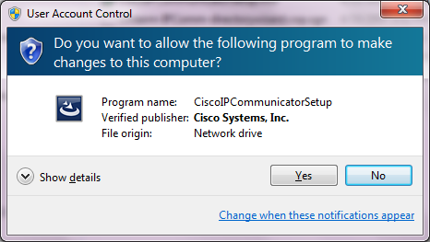
- Click “OK” to this prompt. | 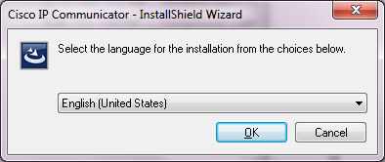
- You will see this screen. Wait until it finishes. (It may take a few minutes.) | 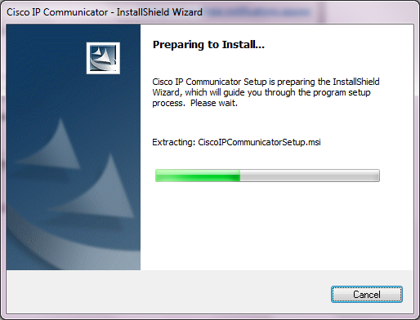
- Click “Next”. | 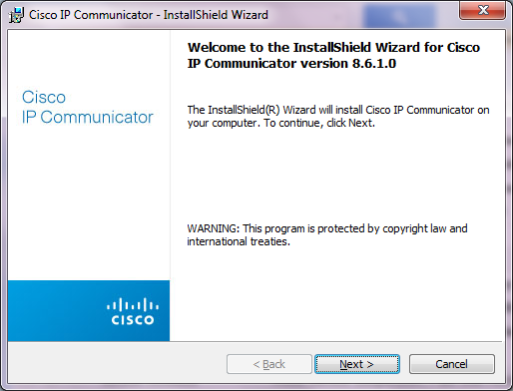
- Accept the License Agreement and click “Next”. | 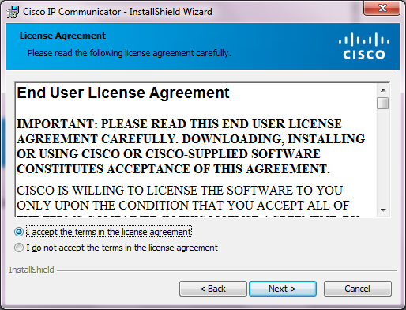
- Click “Next”. | 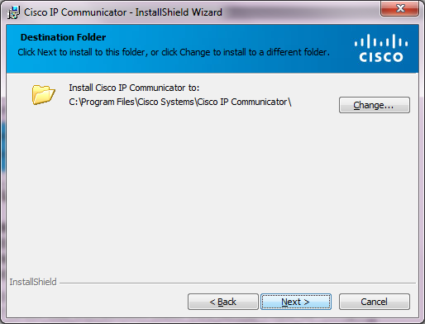
- Click “Install”. | 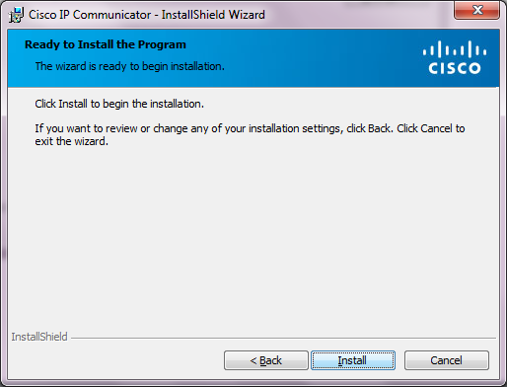
- You will see this screen. Wait until it finishes. (It may take a few minutes.) | 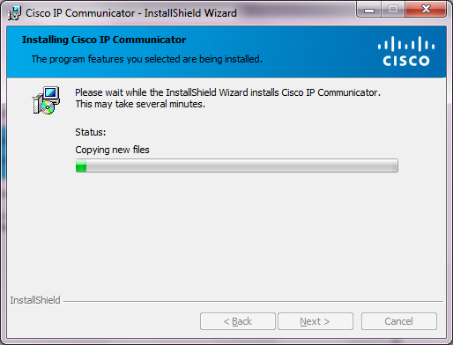
- Make sure the box for “Launch Cisco IP Communicator” is checked and Click “Finish”. | 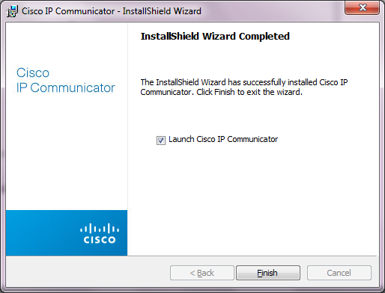
- This will bring up the Tuning Wizard. Click “Next”. | 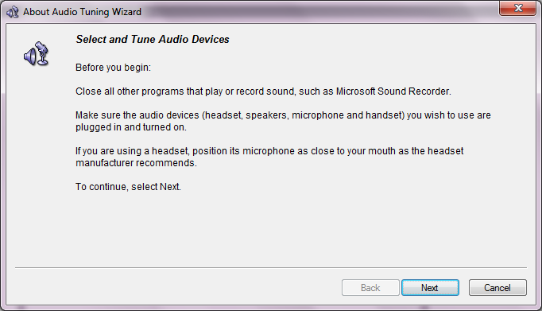
- Make sure that all setting are set for “Default Windows Audio Device” (except for the Ringer) and click “Next”. | 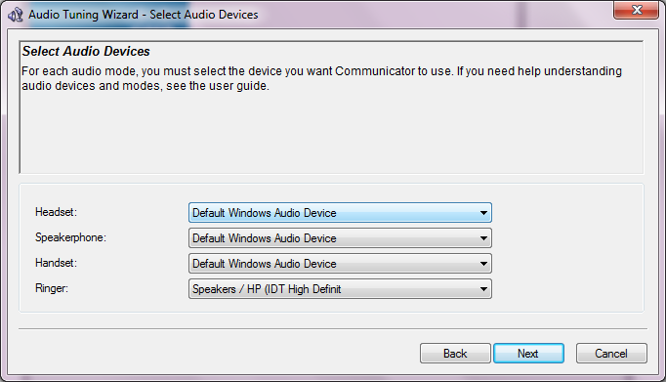
- Click “Play.” You may or may not hear the tones. This okay for now. This will be addressed in Section 2. Click “Next”. | 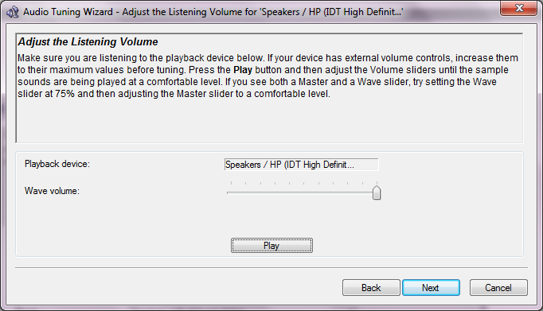
- Click “Test”. Say some words into the microphone. You should see the colored volume meter register your sounds. Click “Next”. | 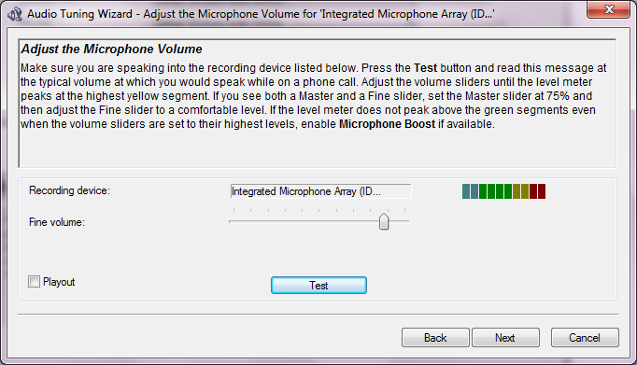
- Click “Finish”. | 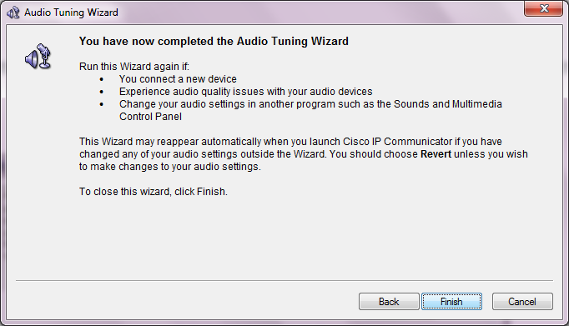
- The CIPC (softphone) will attempt to start. It will fail at first. This is okay. You will see this message. Click “OK”. | 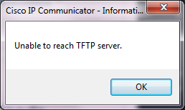
- Configure the network settings as shown. Use your first name and last name, capitalizing the first letter of each (no spaces). Use 172.17.128.12 as the TFTP server. Click “OK”. | 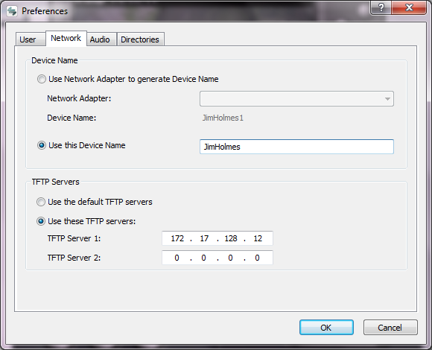
- Assuming the phone has been created on the server, you will see this when it starts: | 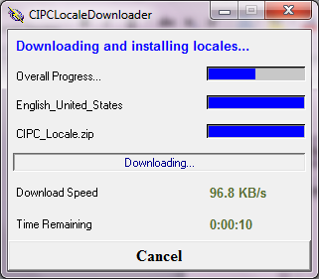
- It should register and you should see working softphone with your extension. If it doesn’t register, email/IM Jim Holmes or Doug Klarman. | 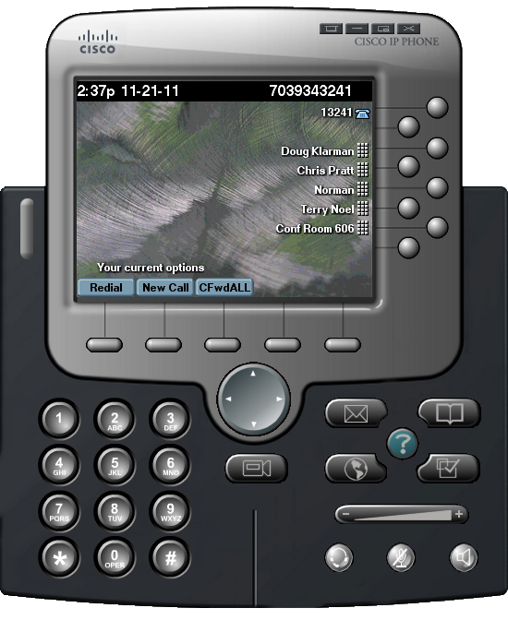

Section II - Sound configuration for Windows 7
- In order to be able to use your USB headset with the soft phone in Windows 7, we will need to edit the “Sound” settings. This is because Windows 7 makes a distinction between a “Default Device” and a “Default Communication Device” for audio.  Open the Control Panel and then click on the “Sound” icon. You should see something like this.  Notice that the laptop speakers are the only icon with a green check mark next to them. | 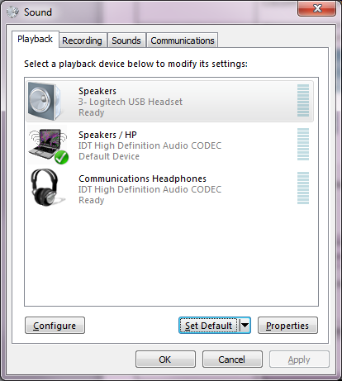
- Identify the icon that represents your headset (it may not be the icon of the headset, as in this case).  To find out, disconnect your head set and one of the icons should disappear. | 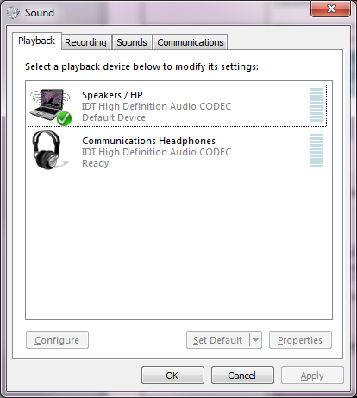
- Reconnect the headset and the icon should reappear. That will be the device that should be set as “Default Communication Device”. | 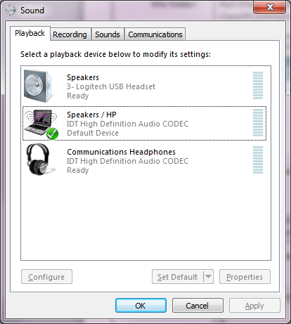
- To make this device the “Default Communications Device”, highlight the device and either:  - Right-click the device and select “Set as Default Communication Device”  - Click the “Set Default” button and select “Default Communication Device”.  You should now be able to use your Cisco soft phone with the USB headset. | 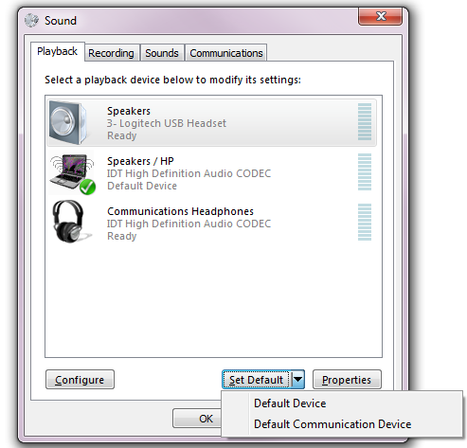

Section III – Troubleshooting/Notes
- Exiting the softphone
Just clicking the “x” in the upper right-hand corner of the application does not exit completely. It is still running in your system tray.

You have to right-click the CIPC icon in your system tray (shown at right) and select “Exit” to exit out completely.
- Sound issues
If you are unable to hear (or be heard) using a USB headset and the Cisco softphone, make sure that:
- Your Cisco softphone’s sound settings are set to use the “Default Windows Audio Device”  Click the “Menu” button in the upper right-hand corner of the soft phone, and select “Preferences”. Then select the “Audio” tab. It should look like the screenshot to the right. | 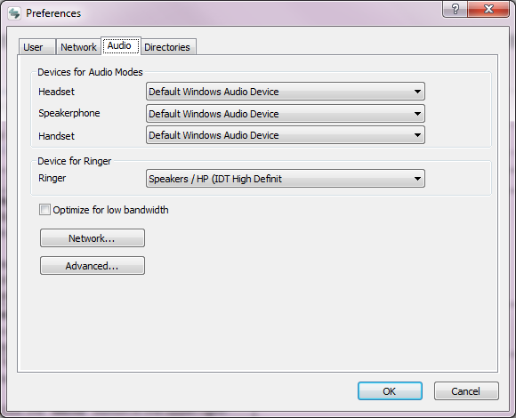
- The correct device is selected as the “Default Communication Device” in the Windows Sound Control Panel.

(See Section II – Sound configuration for Windows 7 above.)

- Web server for local phone configuration  The installation will install a web server for local phone configuration that is not needed, if you wish to remove it, the following is how. | - Open the Windows regedit utility from the Command-line Interface (CLI) or through Start > Run  - In the regedit utility, choose HKEY_LOCAL_MACHINE\SOFTWARE\Cisco Systems, Inc.\Communicator  - From the Edit menu, choose New - DWORD value.  - Create a key named "WebServerDisabled" and set the value to "1".  - In order to enable the web server again, delete this key or set the key to “0”.

